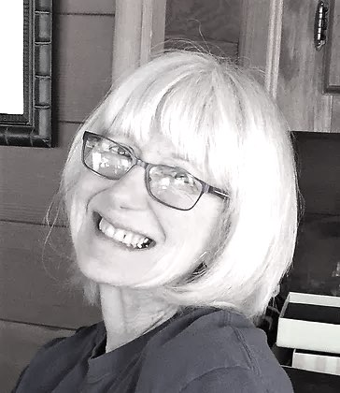
Diana Paque, DPA, CCHt, Certified Clinical Hypnotherapist, Reiki Practitioner, Regressionist 707.319.1396
www.sfbayregressions.com
www.dpconsulting.biz
diana@dpconsulting.biz

Diana Paque Consulting Services

Lives Between Lives® (LBL)/Quantum Consciousness Client Preparation
In preparation for your Life Between Lives® or Quantum Consciousness session, please complete this form and email in advance or bring to your session. You may also print out and handwrite. If handwritten, please make your responses legible and large as these will be used during your session.
Name
Date
Cell phone/Email address

This journey can provide the opportunity for you to explore questions with your soul, your guides and potentially your Council of Wise Beings about your current or past incarnations, challenges and relationships, your soul's character, your soul's journeys and lessons, your purpose and your soul companions. You may also have other questions of a more general nature about the universe, energy, etc.
Each individual that pursues a soul journey will have personal reasons for seeking spiritual regression. You are asked to contemplate questions that are important to you and write these questions out so that I can bring these forward at appropriate times during your session.
Please note that these questions are meant to guide your session and, during your session, discrimination will be used to determine whether to bring forward a question. Also, in some cases, Wiser Beings may have a different opinion about the value, importance or appropriateness of your questions and may take you on an entirely different path.
Please write your questions below.

1

2

3

4

5

6

7

8

During your journeys, you may have the opportunity to meet souls that you have previously incarnated with or who have a role in your current incarnation. For this reason, please provide a list of your "Cast of Characters.” These are the people that you have/ had significant relationships or have influenced your life in an important (positive/negative) manner.
Please provide a few words about the nature of their relationships (Mother, Father, Husband, Wife, etc.) and some key character traits. These don't need to be long-term relationships, for example, even that teacher that made a profound difference in your life may be one of your important soul family members. You don't need to provide a complete family tree, more just the significant or close relationships.
 | Cast of Characters
Name | Relationship | Important Characteristics  (Role, Issues, etc. 3-4 words)

